EVS- GRADE 1

TOPIC: TRANSPORT

What is the Meaning of Transportation?
Transport means carrying people or goods from one place to another place.

How Do You Go to School?
- If you walk to school every day, your school is not far away from your home.
- If you take a bus, school bus, or an auto-rickshaw every day to go to school, that means your school is a little bit far from your home.
- Buses, auto-rickshaws, etc., are modes of transport that help you reach school.
- Ask your father how does he reach his office?
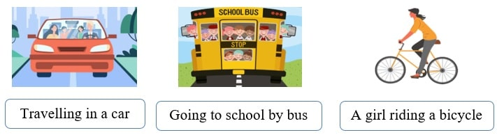

Means of Transport:
The three different modes of transport are—
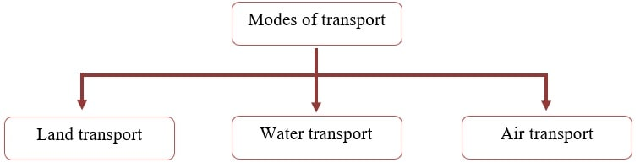

a) Land Transport:
- This mode of transportation includes vehicles that move on land.
- As land transport is cheaper, it is the most common means of transporting people and goods from one place to another.
- Vehicles like buses, cars, bicycles, scooters, etc., move on roads, while trains move on tracks built on the land.

Examples:
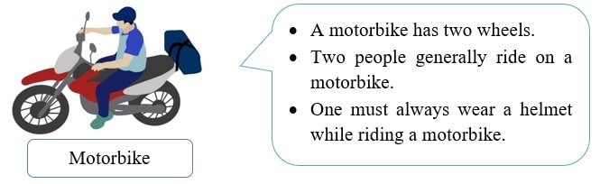
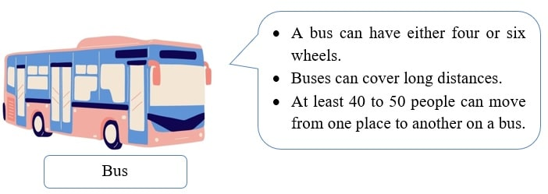
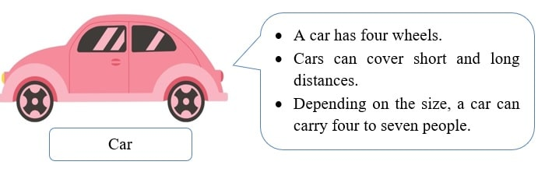
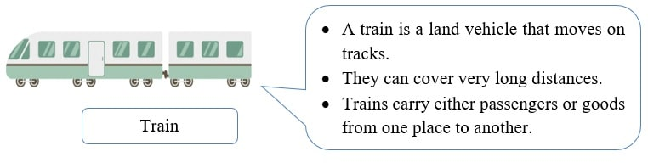
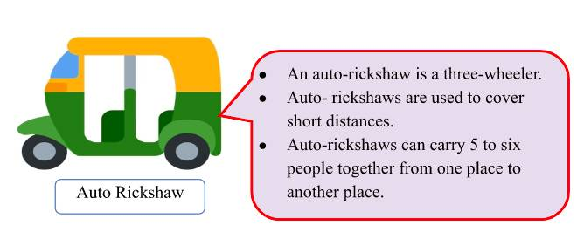

b)Water Transport:
- This mode of transportation involves vehicles moving on water, like rivers, lakes, seas, oceans, etc.
- In earlier times, people depended on water transport for travelling long distances.

Examples:
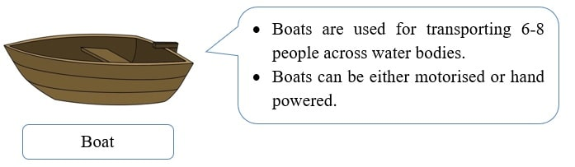
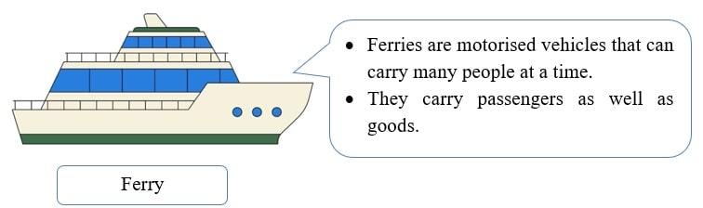
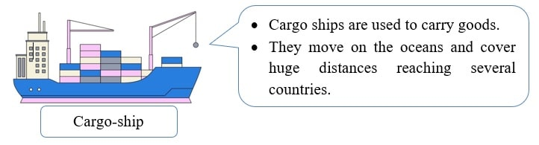
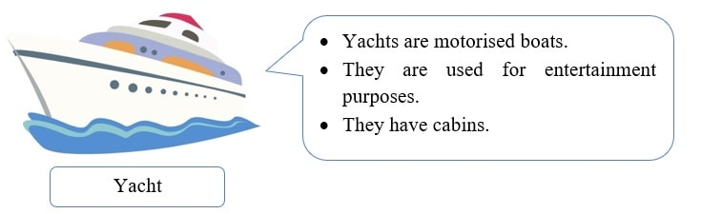
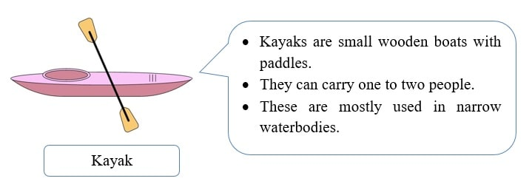

c)Air Transport:
- It is the fastest and most expensive and fastest means of transport.
- People choose air transport to travel to far-off countries within a short time.

Examples:
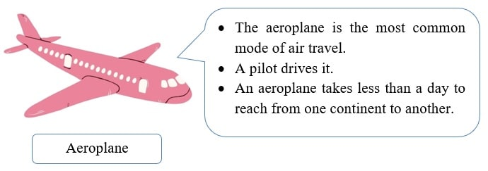
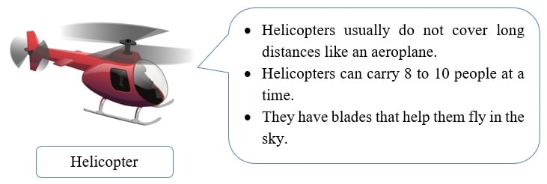
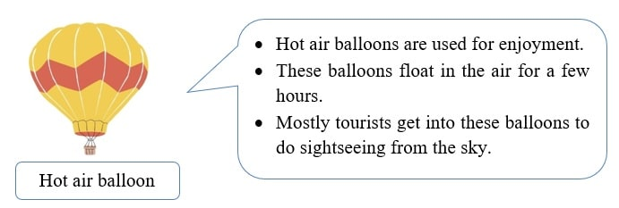

New Words:
Motorised: Something that works with the help of a motor (a machine that drives vehicles).
Cargo: Goods that are carried by ship.

Did You Know?
- Some vehicles can move both on land and water. These types of vehicles are called amphibious vehicles. In this picture, you can see an amphibious bus.
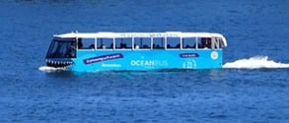
- Submarines are ships that can move underwater. The body of a submarine is similar to that of a fish. Scientists and the military use submarines.
